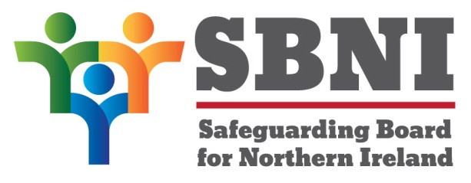
Public Section
Safeguarding Board for Northern Ireland
Thursday 14th January 2016
3:40pm – 4:30pm
The Chestnut Suite
Lagan Valley Island Centre
Lisburn
BT27 4RL
PUBLIC AGENDA
Item Number | Item | Paper | Purpose | Responsibility
 | Welcome |  |  | Chair
 | Preliminaries: Apologies, Quorum, Conflict of Interest, Complaints |  | Noting | Chair
1 20/16P | Previous Minutes | BM19-12.15PM | Approval | Chair
2 20/16P | Matters Arising | BM20-01.16MA | Noting | Chair
3 20/16P | Independent Chair’s Business |  | Noting | Chair
4 20/16P | CSE sub-group  - CSE audit |  | Approval | Chair
5 20/16P | Female Genital Mutilation(FGM) |  | Approval | Chair
Date & Time of Next Meeting:
Thursday 4th February 2016
Dunsilly Hotel, Laburnum 2

