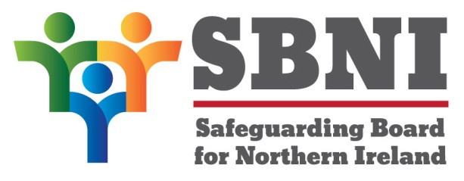
Public Section
Safeguarding Board for Northern Ireland
Thursday 24th March 2016
3:30pm –5:00pm
The Chestnut Suite
Lagan Valley Island Centre
Lisburn
BT27 4RL
PUBLIC AGENDA
Item Number | Item | Paper | Purpose | Responsibility
 | Welcome |  |  | Chair
 | Preliminaries: Apologies, Quoracy, Conflict of Interest, Complaints |  | Noting | Chair
1 21/16P | Previous Minutes | BM20-01.16PM | Approval | Chair
2 21/16P | Matters Arising | BM21-01.16MA | Noting | Chair
3 21/16P | Independent Chair’s Business |  | Noting | Chair
4 21/16P | IAR Template | BM21-01.16P1 | Approval | Dr Devaney
5 21/16P | Information Sharing Agreement (ISA) Options | BM21-01.16P2A  BM21-01.16P2B | Decision | Ms Burke
6 21/16P | Development Day Agenda | BM21-01.16P3 | Decision | Chair
7 21/16P | Publication of public minutes of SBNI Meetings |  | Decision | Chair
8 21/16P | Allegations against staff & volunteers | BM21-01.16P4 | Nominations sought | Ms Burke
Date & Time of Next Meeting:
Board Development Day
26th May 2016
Lagan Valley Island Centre
BT27 4RL

