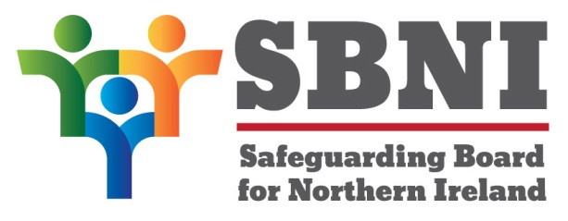
Public Section
Safeguarding Board for Northern Ireland
Thursday 9th June 2016
4:00pm-5:00pm
The Chestnut Suite
Lagan Valley Island Centre
Lisburn
BT27 4RL
PUBLIC AGENDA
Item Number | Item | Paper | Purpose | Responsibility
 | Welcome |  |  | Chair
 | Preliminaries: Apologies, Quoracy, Declaration of Interest, Complaints |  | Noting | Chair
1 22/16P | Previous Minutes | BM21-03.16PM | Approval | Chair
2 22/16P | Matters Arising | BM22-06.16MA | Noting | Chair
3 22/16P | Recruitment | BM22-06.16P1 | Approval | Head of Operations
4 22/16P | Board Development Day |  | Noting | Chair
5 22/16P | e-Safety Strategy | BM22-06.16P2 | Approval for consultation | Head of Operations
6 22/16P | ‘Co – operating to Safeguard Children and Young People 2016’ | BM22-06.16P3 | Discussion | Chair
7 22/16P | Participation |  | Noting | Ms Leeson
8 22/16P | Physical Chastisement |  | Noting | Ms Leeson
9 22/16P | FGM ToR | BM22-06.16P4 | Approval | Ms Turbitt
Date & Time of Next Meeting:
Board Development Day
Wednesday 15th June 2016
The Chestnut Suite
Lagan Valley Island Centre
BT27 4RL

