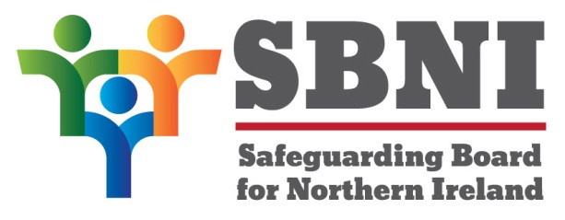
Public Section
26th Meeting of the Safeguarding Board for Northern Ireland
Safeguarding Board for Northern Ireland
Wednesday 22nd February 2017
Public meeting- 3.15pm-5:00pm
The Chestnut Suite
Lagan Valley Island Centre
Lisburn
PUBLIC AGENDA
Item Number | Item | Paper | Purpose | Responsibility
 | Welcome |  |  | Chair
 | Preliminaries: Apologies, Declaration of Interest, Complaints |  | Noting | Chair
1 26/17P | Previous Minutes | BM22-06.16PM | Approval | Chair
2 26/17P | Matters Arising | BM26-02.17MA | Noting | Chair
3 26/17P | Children & Adoption Bill | BM26-02.17P1 | Approval | Chair
4 26/17P | Annual Report 15/16 | BM26-02.17P2 | Noting | Chair
Date & Time of Next Meeting:
22nd March 2017
1:00pm-5:00pm
The Chestnut Suite
Lagan Valley Island Centre
BT27 4RL

