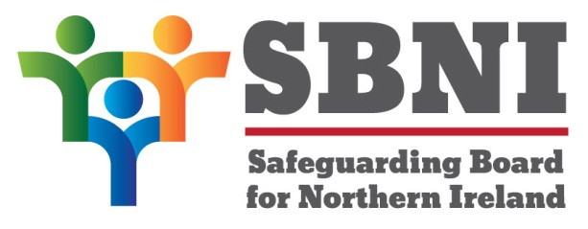
Public Section
27th Meeting of the Safeguarding Board for Northern Ireland
Safeguarding Board for Northern Ireland
Wednesday 22nd March 2017
Public meeting-2:30pm-5:00pm
The Chestnut Suite
Lagan Valley Island Centre
Lisburn
PUBLIC AGENDA
Item Number | Item | Paper | Purpose | Responsibility
 | Welcome |  |  | Chair
 | Preliminaries: Apologies, Declaration of Interest, Complaints |  | Noting | Chair
1 27/17P | Previous Minutes | BM26-02.17PM | Approval | Chair
2 27/17P | Matters Arising | BM27-03.17MA | Noting | Chair
3 27/17P | Independent Chairs’ Business |  | Noting | Chair
4 27/17P | Children & Adoption Bill |  | Noting | Ms Stevenson/Ms McDaniel
5 27/17P | Board Development Day –10th May |  | Noting | Chair
6 27/17P | Marshall Update Report | BM27-03.17P1 | Noting | Chair
7 27/17P | Risk Register | BM27-03.17P2 | Noting | Chair
8 27/17P | Finance Report | BM27-03.17P3 | Noting | Chair
9 27/17P | Year-end Assurance Statement | BM27-03.17P4 | Approval | Chair
Date & Time of Next Meeting:
13th April 2017
11:00am-12 noon
The Oak Room
Lagan Valley Island Centre
BT27 4RL

