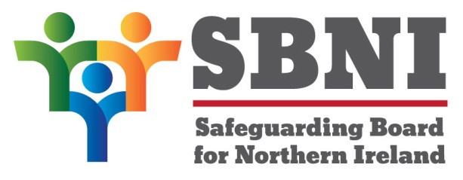
Public Section
29th Meeting of the Safeguarding Board for Northern Ireland
Safeguarding Board for Northern Ireland
Wednesday 20th September 2017
Public meeting – 2:30pm-5:00pm
The Chestnut Suite
Lagan Valley Island Centre
Lisburn
PUBLIC AGENDA
Item Number | Item | Paper | Purpose | Responsibility
 | Welcome |  |  | Chair
 | Preliminaries: Apologies, Declaration of Interest, Complaints |  | Noting | Chair
1 29/17P | Chairs’ Business |  |  | Chair
2 29/17P | Previous Minutes | BM28-06.17PM | Approval | Chair
3 29/17P | Matters Arising | BM29-09.17PMA | Approval | Chair
4 29/17P | Case Conference Sub-Group |  | Noting | Mr Douglas
5 29/17P | Regional Child Protection Policies and Procedures | BM29-09.17P1A  BM29-09.17P1B  BM29-09.17P1C  BM29-09.17P1D  BM29-09.17P1E  BM29-09.17P1F  BM29-09.17P1G  BM29-09.17P1H | Approval | Mr Worthington
6 29/17P | Terms of Reference -Child Protection Sub-Group | BM29-09.17P2 | Approval | Mr Whittle
7 29/17P | SBNI Development Day | BM29-09.17P3 | Noting | Chair
8 29/17P | Finance |  | Noting | Chair
9 29/17P | Risk Register | BM29-09.17P4 | Approval | Chair
10 29/17P | Mid-Year Assurance Statement | BM29-09.17P5 | Approval | Chair
11 29/17P | Communications Report | BM29-09.17P6 | Noting | Chair
Date & Time of Next Meeting:
SBNI Development Day
18th October 2017
The Chestnut Suite
Lagan Valley Island Centre

