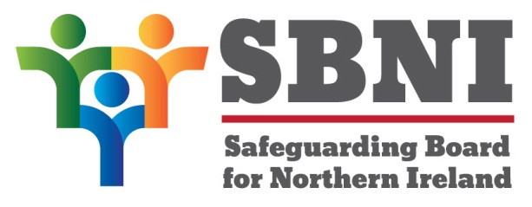
Public Section
30th Meeting of the Safeguarding Board for Northern Ireland
Safeguarding Board for Northern Ireland
Wednesday 6th December 2017
Public meeting – 2:00pm-5:00pm
The Chestnut Suite
Lagan Valley Island Centre
Lisburn
PUBLIC AGENDA
Item Number | Item | Paper | Purpose | Responsibility
 | Welcome |  |  | Chair
 | Preliminaries: Apologies, Declaration of Interest, Complaints |  | Noting | Chair
1 30/17P | Previous Minutes | BM29-09.17PM | Approval | Chair
2 30/17P | Matters Arising | BM30-12.17MA | Approval | Chair
3 30/17P | Chairs’ Business
4 30/17P | Draft Strategic Plan | BM30-12.17P1 | Noting | Chair
5 30/17P | EITP ‘Working Better Together Professional Development’. | BM30-12.17P2 | Approval | Chair
6 30/17P | Finance Report | BM30-12.17P3 | Approval | Chair
7 30/17P | Standardised Assessment Tool for Neglect | BM30-12.17P4 | Approval | Ms Shaw
8 30/17P | CSE Audit Report | BM30-12.17P5A  BM30-12.17P5B | Approval | Chair
9 30/17P | Update on the Jay recommendations | BM30-12.17P6 | Noting | Chair
10 30/17P | Strategy for Raising Awareness and Implementation of Core Policy and Procedures | BM30-12.17P7 | Noting | Chair
11 30/17P | Draft Equality and Disability Action Plans | BM30-12.17P8 | Approval for consultation | Chair
12 30/17P | Equality- enhanced SLA | BM30-12.17P9 | Approval | Chair
Date & Time of Next Meeting:
SBNI Development Day
21st February 2018
The Chestnut Suite
Lagan Valley Island Centre

