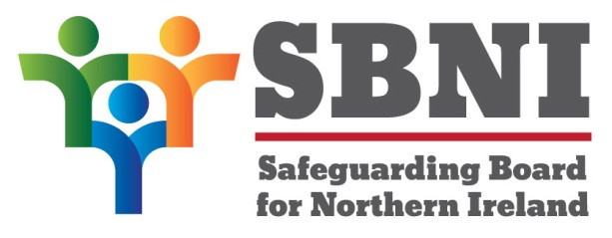
Public Section
32nd Meeting of the Safeguarding Board for Northern Ireland
Safeguarding Board for Northern Ireland
Wednesday 21st March 2018
Public meeting – 2.30pm-5.00pm
The Chestnut Suite
Lagan Valley Island Centre
Lisburn
PUBLIC AGENDA
Item Number | Item | Paper | Purpose | Responsibility
 | Welcome |  |  | Chair
 | Preliminaries: Apologies, Declaration of Interest, Complaints |  | Noting | Chair
1 32/18P | Previous Minutes | BM31-02.18PM | Approval | Chair
2 32/18P | Matters Arising | BM32.03.18MA | Approval | Chair
3 32/18P | Signs of Safety |  | Noting | Ms Mahon
4 32/18P | Strategic Plan | BM32.03.18P1 | Noting | Ms McKenzie
5 32/18P | Neglect Strategy | BM32-03.18P2A  BM32-03.18P2B | Approval | Chair
6 32/18P | Development Day agenda | BM32-03.18P3 | Noting | Chair
7 32/18P | EITP ‘Working Better Together Professional Development Framework’ Scoping Paper | BM32-03.18P4 | Noting | Chair
8 32/18P | Finance | BM32-03.18P5 | Noting | Chair
9 32/18P | Annual Report |  | Noting | Chair
10 32/18P | ToR Domestic Violence Sub-Group | BM32-03.18P6 | Approval | Chair
11 32/18P | Implications of Equal Protection-Physical Punishment |  | Noting | Chair
Date & Time of Next
SBNI Development Day:
9th May 2018
The Chestnut Suite
Lagan Valley Island Centre

