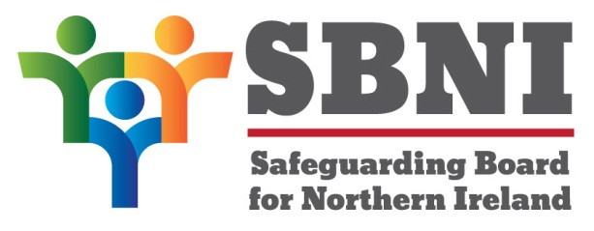
Public Section
34th Meeting of the Safeguarding Board for Northern Ireland
Safeguarding Board for Northern Ireland
Wednesday 19th September 2018
Public meeting – 2.30pm-5.00pm
The Chestnut Suite
Lagan Valley Island Centre
Lisburn
PUBLIC AGENDA
Item Number | Item | Paper | Purpose | Responsibility
 | Welcome |  |  | Chair
 | Preliminaries: Apologies, Declaration of Interest, Complaints |  |  | Chair
1 34/18P | Previous Minutes | BM33-06.18M | Approval | Chair
2 34/18P | Matters Arising | BM34-09.18MA | Approval | Chair
3 34/18P | EITP WKS4 – Trauma Informed Practice – Professional Development Project Update | BM34-09.18P1 | Noting | Mr Simon Rogers
4 34/18P | Terms of Reference – SBNI Governance Group | BM34-09.18P2 |  | Mr Gerard McGuckian
5 34/18P | Concern Hubs/Mash Project presentation |  | Noting | Inspector Mark Peters, PSNI
6 34/18P | Finance Report | BM34-09.18P3 | Approval | Chair
7 34/18P | Costed Business Plan 18/19 | BM34-09.18P4 | Approval | Chair
8 34/18P | Children in need –Emergency essentials programme |  | Noting | Mr Paul McAfee
9 34/18P | Peer Mentoring Scheme | BM34-09.18P5 | Noting | Chair
10 34/18P | Board Development Day  - Draft Agenda 17.10.18 | BM34-09.18P6 | Approval | Chair
11 34/18P | A.O.B
Date of next meeting:
Board Development Day 17th October 2018
The Chestnut Suite
Lagan Valley Island Centre

