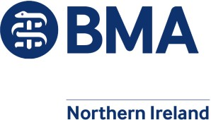

To all GP Practices Sent via Email | Directorate of Integrated Care Health and Social Care Board 12-22 Linenhall Street  Belfast BT2 8BS  Tel: 028 95 363926  Fax: 028 95 363126  Web Site: www.hscboard.hscni.net  29th January 2019
Colleagues,

RE: Generic General Practice Safeguarding Policy

NIGPC has worked with the Directorate of Integrated Care at the HSCB with the support of the Safeguarding Board for Northern Ireland [SBNI] to produce the attached “Generic” Practice Safeguarding Policy with its appendices. It is intended to act as a basic policy document for general practice in matters relating to safeguarding of children. A predominant feature of this policy document is the email contact details for the SBNI Core Policies and Procedures. These form the main documents relating to safeguarding protocols for all agencies and individuals in Northern Ireland working with children and their families. Therefore, these policies and procedures also apply to GPs, as they engage with social services in relation to dealing with children in need and children at risk.

All GP Practices in Northern Ireland should have a Practice Policy for Safeguarding specific for their practice which they share with all members of the practice and anyone who comes into work in the practice (including but not limited to, sessional GPs, GP trainees and Allied Health Professionals) whose work will potentially bring them in contact with children and young people. Furthermore, the practice should ensure that its policy document remains up to date. (The generic document will be available on the HSCB GP Intranet site and the SBNI website).

Practices and practitioners may wish to expand this generic document for their practice. It should also be noted that there are other safeguarding resources such as the Safeguarding Toolkit provided by RCGP which are significantly more comprehensive.
However, it should be remembered if using these for your practice policy document they will need adapted for use in Northern Ireland in relation to the SBNI Policies & Procedures and the laws in this area specific to Northern Ireland.

All health staff who come into contact with children and their families have a minimum responsibility to:

- Have the competencies to recognise and understand what constitutes child maltreatment
- Recognise the potential impact of parent/carers physical and mental health on the well-being of the child.
- Act as an effective advocate for the child.
- Be clear about their own and other colleague’s roles and responsibilities and professional boundaries.
- Be aware of your local Safeguarding Children’s Board Policy and Procedures*.
- Know where to seek expert advice and support by knowing the contact details of your local/organisations and Named and Designated Professionals.
- Know when and how to make a referral to your local Children’s Social Care Service.
- Know when and how to share information about child welfare concerns.
- Know how to record details of any concerns and any actions you take including reasons for no action.

GPs should consider their safeguarding training requirements within their annual appraisal process.

We hope the documents provided are of assistance to practices in helping to fulfil their safeguarding responsibilities and hope that they enhance the professions work to safeguard and promote the welfare of children and young people.

Yours sincerely,

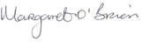
Dr Alan Stout Dr Margaret O’Brien
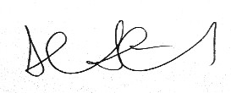
Chair, NIGPC Assistant Director of Integrated Care Head of General Medical Services Responsible Officer, HSCB

*Safeguarding Board for Northern Ireland https://www.proceduresonline.com/sbni/

