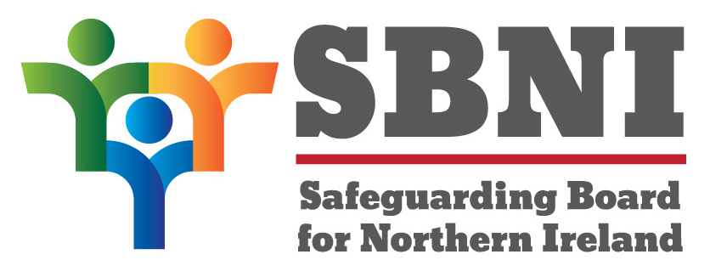

Learning from Case Management Reviews

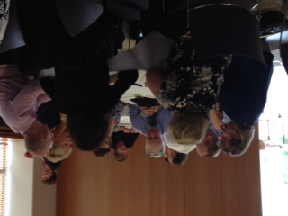
A regional event to Disseminate Learning from 10 Case Management Reviews (CMRs) undertaken by the Safeguarding Board for Northern Ireland (SBNI) was held on 30th June 2017 by the SBNI. The event was well attended with over 100 delegates from various Statutory and Voluntary Agencies. Some photographs taken at the event are displayed.
Ms Bernie McNally Independent Chair of the SBNI opened the event and explained that the aim was to share the learning from CMRs undertaken by the SBNI. Ms McNally explained that the purpose of CMRs was on learning, to make the system better for children and young people in Northern Ireland and was not about apportioning blame.
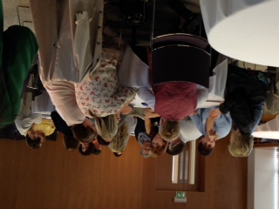
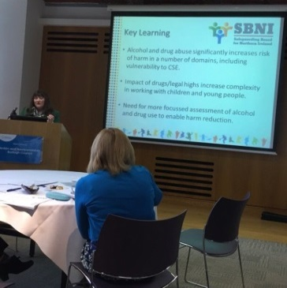
Mr Andrew Thomson Independent Chair of the CMR Panel gave the legal context to CMRs and provided some statistical details.
Mrs Lesley Walker CMR Panel Member and Ms Margaret Burke SBNI Professional Officer then discussed the learning from each of the CMRs outlining the areas of good practice and the key learning. An overview of the cross cutting themes from all the CMRs and what has changed as a result was also outlined.

Each Safeguarding Panel area is in the process of undertaking events to disseminate the learning from CMRs at local level. The main learning from these CMRs is outlined below.

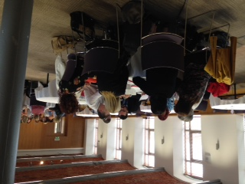
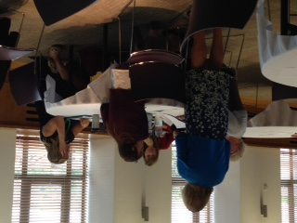

CMR ONE
Areas of Good Practice
- The prompt action of the Health Visitor when bruising was brought to her attention.
- A Doctor on the third admission, completed thorough records, liaised with nursing staff, the consultant paediatrician and considered NAI as a possible cause for bruising.
- The social worker ably managed the difficult relationships between the baby’s mother and extended family.
Key Learning
- Importance of using historical information and avoiding ‘start again’ syndrome with new babies.
- Residential Assessments should only occur when a robust, community based, comprehensive/holistic assessment has determined it as appropriate.
- Assessments need to consider new partners and be undertaken in a timely manner.
- When child abuse is seen as a considered alternative to an organic diagnosis, a multi-agency/disciplinary strategy discussion should always be held.
- Need for robust, professional challenge in dealing with differential diagnosis.
- Need for structured hospital recording formats for nursing staff to monitor visiting/rooming in of parents and/or carers of ‘at risk’ babies.
- Need for child protection training for all grades of medical staff involved with babies and children.
CMR TWO
Areas of Good Practice
- Prompt response to GP’s referral re: mother’s suicidal ideation in relation to older child.
- A comprehensive Mental Health assessment was conducted and good liaison with Gateway.
- Health Visitor responded promptly to alert from hospital that baby with no known HV had been seen in ED.
- Paediatrician who treated older sibling was thorough in assessment and liaison with GP, CDC and AHP’s.
- ‘Think Family’ approach adopted within the Trust.
Key Learning
- GP needs to be ‘linchpin’ in the network of services with a family.
- Social Workers to continually test the robustness of the Child Protection Safety Planning arrangements and ensure a safeguarding adult is identified and briefed re: any potential risks.
- This should include an assessment of the other parent/carer’s understanding of the risk and their willingness to take responsibility for child’s safety.
- Gaps identified in information available to professionals, and links between parents’ and children’s records.
- Undertaking a collateral history is imperative in mental health cases.
- Circumstances where a parent talks of killing themselves and their child should always be treated seriously and warrants multi-disciplinary joint-planning discussions.
- A co-ordinated care plan should be agreed.
- Family Health Assessment needs to be a reflective process, completed after significant mental health assessments.
- Role of Hospital Social Workers was insufficiently clear. Need to consider how they can meet needs of parents for emotional support in coming to terms with developmental delay in their children.
- Importance of using interpreters, even when a parent’s English is good.
CMR THREE
Areas of Good Practice
- Appropriate threshold for instigating Child Protection Procedures ensuring plans resulted in timely improvement in children’s circumstances.
- Evidence of agencies referring their concerns at specific points.
Key Learning
- Need to read historic case files, use of transfer summaries and meetings.
- Professionals’ understanding of the long-term and cumulative effects of neglect and abuse – role of Community Paediatricians.
- Need to focus on the big picture – patterns of repeated harm and abuse, importance of chronologies and the risk of ‘start again’ syndrome.
- Robust understanding of CP Procedures, including Joint Protocol and formal Investigation of neglect and allegations made.
- Children need to be kept at the centre of the process – understanding what life is like from the child’s perspective.
- Need for robust governance systems to monitor quality – review of long-term cases, e.g. Children on Register 2 Yrs. +.
- Court thresholds for Neglect – Impact on practice – need to seek early legal advice.
- Important role of G.P.’s in Safeguarding.
- Full explanation of the background of adults.
- Lack of comprehensive assessment at key points.
- Need for greater confidence in dealing with difficult, resistant and intimidating parents.
- Child Protection Plans need to be outcome specific and time-limited, incorporating contracts.
- Understanding of the additional needs of children with learning disabilities.
- Need for informed management supervision and monitoring of practice and outcomes in complex and chronic cases.
- Independent review needed (long history with re-registrations, lack of improvement, ongoing concerns by other agencies).
- Increased levels of cooperation do not equate with greater safety/care for children.
- Holistic and child-centred assessment of children’s medical and developmental needs.
- Greater clarity re: role of PSNI/PPS in relation to chronic neglect cases (Thresholds).
- Robust governance processes to ensure adherence to policy, procedures and standards of practice through supervision, audit and monitoring.
- Importance of professional challenge and escalation of concerns.
- Community paediatrics to make an informed contribution to neglect cases.
- Greater clarity re: regional thresholds for legal proceedings in chronic neglect cases.
CMR FOUR
Areas of Good Practice
- GP reported mother’s attempted suicide immediately and fact she was caring for child.
- Immediate referral from Mental Health to Police who visited immediately and referred onto Gateway and Hospital Social Worker.
Key Learning
- Clarity required re: use of Safety Plans. Must not be used as an alternative to Child Protection Procedures.
- Agreements should be in writing and communicated to all key professionals.
- Escalation/action required when any plan or agreement is breached.
- Historical files need to be retrieved and information analysed using UNOCINI assessment.
- The necessity of tracking Initial Assessments not completed within 10 working days.
- Importance of ensuring ‘Think Family’ is fully integrated (Adult Services and Primary Care).
- Need to raise awareness amongst GP’s of national best practice in support of patients with prescription or non-prescription drug addiction.
CMR FIVE
Areas of Good Practice
- Aspects of multi-agency assessment and management of risk.
- During missing episodes Inter-agency efforts in relation to searching and locating young person robust.
- Barnardo’s ‘Safe Choices ‘commended for its approach.
- Residential staff particularly the Key Worker had a good relationship with young person.
- PSNI investigation of CSE.
Key Learning
- Alcohol and drug abuse significantly increases risk of harm in a number of domains, including vulnerability to CSE.
- Impact of drugs/legal highs increase complexity in working with children and young people.
- Need for more focussed assessment of alcohol and drug use to enable harm reduction.
- Need for training and awareness of neuroscience and interpersonal neurobiology to have a trauma informed approach for Looked After Children in Residential Care.
- The needs, rights and risks of all young people living in a residential setting need to be balanced with those of another young person being considered for admission.
- Model of practice used should be reviewed with a view to its application regionally.
- Investigation of alleged CSE is a complex and difficult task. It is resource intensive and requires specialist investigators.
- Decisions on a child’s needs must be based on robust risk assessment.
CMR SIX
Areas of Good Practice
- Sharing of information and decision making within and between agencies was regular and detailed.
- Police and hospital Emergency Department staff had concerns about mother’s mental health and undertook appropriate action.
- The original child protection issue was appropriately dealt with by the Children’s Disability Team.
Key Learning
- Impact of deteriorating mental health on parenting capacity and the need to recognise/be aware of indicators and previous history.
- Need for all services to implement ‘Think Family’ in their practice.
- Need to contact professional staff if information is noted on IT systems, to inform assessment and analysis of risk.
- Interface between Family Intervention and Children’s Disability Services. Need for co-ordinated case management and clear transfer process.
- Need to engage father’s in assessment and case management.
- Need for clear and documented Family Support Plans with responsibilities clearly outlined.
- Child protection policy and procedures need to be implemented and have appropriate processes in place to ensure compliance.
- Training on Guidance Documents and Protocols for staff should be reviewed to ensure they are appropriately delivered and audited.
- Process to ensure availability of information required for Child Protection Conferences needs reviewed.
- Training and guidance for staff should be reviewed regarding information entered on SOSCARE where a parent has a conviction for a Relevant Offence.
- Guidance to staff for patients presenting with Self Harm/Mental Health issues at Emergency Departments should be reviewed. Similar guidance should be produced for those working outside ‘office hours’.
- Actions required by Review Child Protection Conferences should be managed and audited to ensure compliance, particularly in relation to deregistration.
- Guidance and Protocols on the completion of UNOCINI documents should be reviewed.
- The UNOCINI referral form should include the outcome of assessments undertaken.
- The protocol ‘Responding to the Needs of Children whose Parents have Mental Health or Substance Misuse Issues’ should be fully implemented, reviewed and its impact audited.
CMR SEVEN
Areas of Good Practice
- All members of staff involved with young person committed to providing professional care and a safe environment.
- Evidence of good communication between field work teams, residential units, and family.
- High level of inter-disciplinary working.
- Strategy and risk management meetings occurred appropriately.
Key Learning
- Need for regional guidance for staff working with children who are looked after or on the Child Protection Register, regarding managing threats against a child especially from paramilitaries.
- PSNI information systems should be reviewed in relation to access to such issues as bail conditions, missing from care, wanted, and current threats.
- Actions agreed at key meetings should be appropriately documented and disseminated.
- Compliance and ownership by Agencies of actions agreed at key meetings.
- Comprehensive risk assessment and grading process needed for those children who ‘go missing’ but their whereabouts are known and who are considered to be at risk of significant harm.
- Review needed into the type and availability of secure/residential accommodation - opportunities to develop therapeutic relationships with children.
- Development of Co-ordinated Multi-agency Child Protection Plans for children under threat, which align with current Child Protection processes.
CMR EIGHT
Areas of Good Practice
- Staff working directly with family commended for their commitment and perseverance.
- Excellent multi-disciplinary liaison, effective communication and good multi-agency planning between the professionals across a number of agencies.
- Consistency in the recording of significant events across agencies.
Key Learning
- Greater awareness of the dangers of co-sleeping, particularly in relation to families where parents smoke and/or misuse substances.
- Sharing information in relation to children and adults at case conferences to inform risk assessment.
- Critical role and engagement of GPs in safeguarding, particularly regarding parental functioning.
- Need to reinforce awareness that safeguarding is everyone’s business.
- Issue of toxicology screening of parents in the event of a sudden unexplained death in infancy.
- Thresholds for instigating Court Proceedings met.
CMR NINE
Areas of Good Practice
- Some good examples of inter-disciplinary work.
- Excellent response to the incident by a member of the public, Emergency Services PSNI, Social Workers and Hospital Staff.
Key Learning
- Accessing historical information to inform assessment and analysis.
- Level of concern needs to be conveyed in referrals to Social Services.
- Link between mental health and safeguarding.
- Professionals visiting families should be aware of child safety, hazards and dangers, and reinforce these to parents.
- All disciplines and agencies should ensure that a mechanism exists for checking with parents if other services/agencies are involved with their family and consent sought to contact these services.
- A clear mechanism should be established between Mental Health and Health Visiting Services to ensure appropriate interventions are in place.
- Inter-disciplinary agreement for a staged withdrawal of services and a point of contact identified for vulnerable families, should they require advice or assistance in the future.
- Oversight system to manage referrals to Gateway should continue and be subject to on-going audit.
- The role and processes relating to Family Support Hubs should be fully understood by staff and embedded.
CMR TEN
Areas of Good Practice
- Professionals involved with the family were experienced individuals.
- Consistency in professionals involved in the case.
- High level of commitment and dedication by staff when faced with an exceptionally challenging and complex case.
Key Learning
- Cases of denied child abuse are difficult and complex.
- Risk assessment needs to be at the core of decision making in child protection work.
- Tension between approaches to assessing children in need and risk assessment.
- Holding a Fact Finding Hearing and written judgements in public law cases would greatly assist in cases of denied abuse.
- Implementation and training needed regarding the revised guidance on “Protecting Looked After Children”.
- Those who might assist in the assessment and analysis of risk should be invited to each LAC Review.
- A review and recording of cases of denied abuse covering key stages, outcomes and methodologies employed should be undertaken.
- Multi-disciplinary practice guidance for working with denied abuse should be developed.
- Frequency of LAC reviews should take into account the complexity of each case.
Cross Cutting Themes
A number of cross cutting themes have been identified as follows:
- Majority of cases of child death or serious abuse are known or previously known to HSC Trusts.
- Need to understand what life is like from the child’s perspective.
- Lack of Comprehensive Assessments pulling together all the historical and relevant information and ensuring robust analysis of same.
- Understanding impact of new partners and need to engage fathers.
- Level of concern needs to be communicated in a relevant and appropriate manner.
- Understanding the full impact of parental adversities and their impact/likely impact on parenting.
- Critical role of GPs and information they hold for informing assessment and analysis.
- Mental Health of parents.
- Child/Children with Disability.
- Historical context not given sufficient prominence.
- Start Again Syndrome.
- Issues re: Information Systems and/or need for improved Inter-agency communication.
- Need for robust line management oversight of all plans and supervision of staff.
- Use of written agreements and Safety Plans.
- Engaging challenging and difficult parents.

