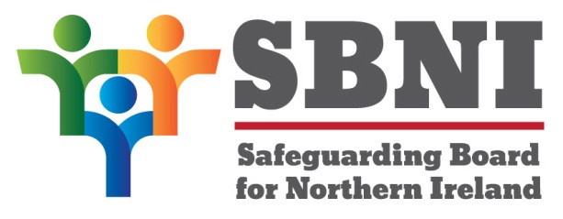
Public Section
43rd Meeting of the Safeguarding Board for Northern Ireland
Wednesday 14th October
Public meeting – 2.15pm-3.15pm
PUBLIC AGENDA

Item Number | Item | Paper | Purpose | Responsibility
 | Welcome |  |  | Chair
 | Preliminaries: Apologies, Declaration of Interest, Complaints |  |  | Chair
1 43/20P | Previous Minutes | BM42-09.20PM | Approval | Chair
2 43/20P | Matters Arising | BM43-10.20MA |  | Chair
3 43/20P | Annual Report | BM43-10.20P1 | Approval | Chair
4 43/20P | Equally Safeguarded | BM43-10.20P2 | Presentation & Noting | Mr David Douglas Chair of Domestic Abuse Committee
5 43/20P | Update on CSE Action Planning |  | Noting | Chief Superintendent Anthony McNally
6 43/20P | Draft Adoption and Children’s (Northern Ireland) Bill | BM43-10.20P3 | Noting | Chair
7 43/20P | AOB
Date of next meeting:
2nd December 2020
3.00pm

