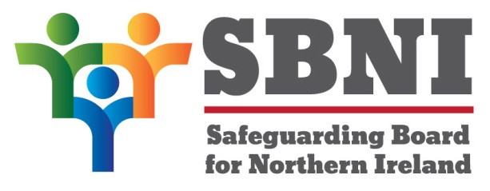
Public Section
37th Meeting of the Safeguarding Board for Northern Ireland
Wednesday 17th April 2019
Public meeting – 2.00pm-5.00pm
The Chestnut Suite
Lagan Valley Island Centre
Lisburn
PUBLIC AGENDA
Item Number | Item | Paper | Purpose | Responsibility
 | Welcome
 | Preliminaries: Apologies, Declaration of Interest, Complaints |  |  | Chair
1 37/19P | Previous Minutes | BM36-02.19PM |  | Chair
2 37/19P | Matters Arising | BM37-04.19MA |  | Chair
3 37/19P | EITP Update |  | Noting | Mr Simon Rodgers
4 37/19P | CSE Evaluation | BM37-04.19P1 | Noting | Ms Teresa McAllister
5 37/19P | Finance Update | BM37-04.19P2 | Noting | Chair
6 37/19P | Year End Assurance Statement | BM37-04.19P3 | Approval | Chair
7 37/19P | Neglect Strategy and Sub-group update | BM37-04.19P4 | Approval | Ms Dawn Shaw
8 37/19P | Board Development Day | BM37-04.19P5 | Approval | Chair
9 37/19P | Update on Governance Committee  - Terms of Reference for Governance Committee | BM37-04.19P6 | Approval | Mr Gerry Guckian
Date & Time of next
SBNI meeting:
19th June 2019
The Chestnut Suite
Lagan Valley Island Centre

