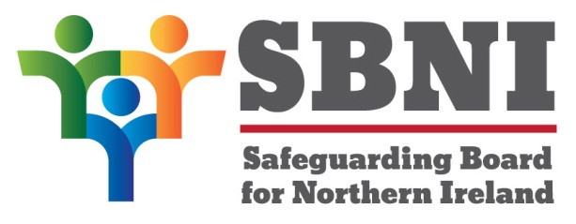
Public Section
41th Meeting of the Safeguarding Board for Northern Ireland
Wednesday 19th February 2020
Public meeting – 2.15pm – 4.30pm
The Chestnut Suite
Lagan Valley Island Centre
Lisburn
PUBLIC AGENDA
Item Number | Item | Paper | Purpose | Responsibility
 | Welcome
 | Preliminaries: Apologies, Declaration of Interest, Complaints |  |  | Chair
1 41.20P | Previous Minutes | BM40-12.19M |  | Chair
2 41.20P | Matters Arising | BM41-02.20MA |  | Chair
3.41.20P | SBNI Board Effectiveness & Presentation |  | Noting | Mr Gerry Guckian
4.41.20P | Risk Register | BM41-02.20P1 | Noting | Mr Gerry Guckian
5.41.20P | May Development Day | BM41-02.20P2 | Noting | Chair
6.41.20P | Home Office MOU | BM41-02.20P3 | Approval
7.41.20P | Neglect Training Papers | BM41-02.20P4  BM41-02.20P5  BM41-02.20P6  BM41-02.20P7  BM41-02.20P8  BM41-02.20P9  BM41-02.20P10 | Approval | Ms Emily Roberts
8.41.20P | SBNI Newsletter | BM41-02.20P11 | Noting | Chair
9 41.20P | Finance | BM41-02.20P12 | Approval | Chair
10.41.20P | Communication from Eilis McDaniel Re: Definition of Harm | BM41-02.20P13 | Noting | Chair
11.41.20P | AOB
Date & Time of next
SBNI meeting:
8th April 2020
The Chestnut Suite
Lagan Valley Island Centre

