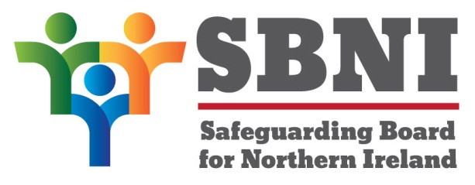
Public Section
38th Meeting of the Safeguarding Board for Northern Ireland
Wednesday 19th June 2019
Public meeting – 3.00pm-5.00pm
The Chestnut Suite
Lagan Valley Island Centre
Lisburn
PUBLIC AGENDA
Item Number | Item | Paper | Purpose | Responsibility
 | Welcome
 | Preliminaries: Apologies, Declaration of Interest, Complaints |  |  | Chair
1 38/19P | Previous Minutes | BM37-06.19PM |  | Chair
2 38/19P | Matters Arising | BM38-06.19MA
3 38/19P | Risk Register and TOR Governance Committee | BM38-06.19P1 | Noting | Mr Guckian
4 38/19P | DV Definition of Harm | BM38-06.19P2 | Approval | Ms McAllister
6 38/19P | CSE Up Date | BM38-06.19P3 | Approval | D/Chief Superintendent Paula Hillman
7 38/19P | Annual Report | BM38-06.19P4 | Noting | Chair
8 38/19P | Communication and Engagement Report | BM38-06.19P5 | Noting | Chair
8 38/19P | Consultation on Information Sharing Agreement | BM38-06.19P6 | Noting | Chair
9 38/19P | Finance | BM38-06.19P7 | Noting | Chair
Date & Time of next
SBNI meeting:
25th September 2019
The Chestnut Suite
Lagan Valley Island Centre

