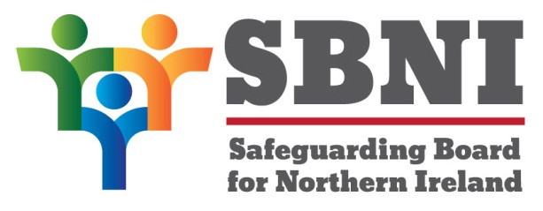
Public Section
39th Meeting of the Safeguarding Board for Northern Ireland
Wednesday 25th September 2019
Public meeting – 3.00pm-5.00pm
The Chestnut Suite
Lagan Valley Island Centre
Lisburn
PUBLIC AGENDA
Item Number | Item | Paper | Purpose | Responsibility
 | Welcome
 | Preliminaries: Apologies, Declaration of Interest, Complaints |  |  | Chair
1 39/19P | Previous Minutes | BM38-06.19M |  | Chair
2 39/19P | Matters Arising | BM39-09.19MA |  | Chair
3 39/19P | Business Plan OBA Request | BM39-09.19P1 | Noting
4 39/19P | SBNI Engagement with Judiciary | BM39-09.19P2 | Noting
5 39/19P | MoU | BM39-09.19P3 | Approval
6 39/19P | JAY DOH Proposal | BM39-09.19P4 | Approval
7 39/19P | Mid-Year Assurance Statement | BM39-09.19P5
8 39/19P | Finance Update | BM39-09.19P6 | Approval
9 39/19P | EITP Update | BM39-09.19P7 | Noting | Mr Simon Rogers
Date & Time of next
SBNI meeting:
4th December 2019
The Chestnut Suite
Lagan Valley Island Centre

