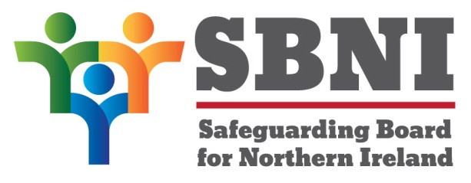
Public Section
44th Meeting of the Safeguarding Board for Northern Ireland
Wednesday 2nd December 2020
Public meeting – 2.30pm - 4pm
PUBLIC AGENDA

Item Number | Item | Paper | Purpose | Responsibility
 | Welcome |  |  | Chair
 | Preliminaries: Apologies, Declaration of Interest, Complaints |  |  | Chair
1 44/20P | Previous Minutes | BM43-10.20PM | Approval | Chair
2 44/20P | Matters Arising | BM44-12.20MA | Approval | Chair
3 44/20P | CSE Action Planning | BM44-12.20P1 | Noting | D/Chief Superintendent Anthony McNally
4 44/20P | Child Death Overview Panel | BM44-12.20P2 | Noting | Chair
5 44/20P | Finance Update | BM44-12.20P3 | Noting | Chair
8 44/20P | Resolution and Escalation Policy | BM44-12.20P4 | Noting | Ms Maura Dargan
8 44/20P | SBNI Website Re-design |  | Noting | Chair
8 44/20P | Recruitment to SBNI Central Support Team |  | Noting | Chair
 | AOB
Date of next meeting:
17th February 2021

