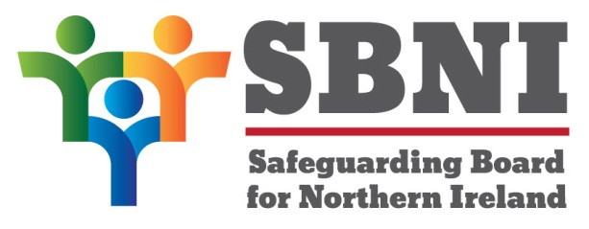
Public Section
40th Meeting of the Safeguarding Board for Northern Ireland
Wednesday 4th December 2019
Public meeting – 2.15pm – 4.30pm
The Chestnut Suite
Lagan Valley Island Centre
Lisburn
PUBLIC AGENDA
Item Number | Item | Paper | Purpose | Responsibility
 | Welcome
 | Preliminaries: Apologies, Declaration of Interest, Complaints |  |  | Chair
1 40.19P | Previous Minutes | BM39-09.19PM |  | Chair
2 40.19P | Matters Arising | BM40-12.19PMA |  | Chair
3 40.19P | CSE Report | BM40-12.19P1 | Approval | Ms Marcella Leonard/ Ms Teresa McAllister
4.40.19P | E-Safety | BM40-12.19P2 | Noting | Ms Teresa McAllister
5 40.19P | EITP Update and Next Steps |  | Noting | Ms Helen McKenzie
6 40.19P | Pre-Mobile Babies | BM40-12.19P3  BM40-12.19P4 | Approval | Ms Margaret Burke
7 40.19P | Finance | BM40-12.19P5 | Noting | The Chair
8 40.19P | Members Agreement | BM40-12.19P6 | Noting | The Chair
9 40.19P | SBNI Board Dates 2020 | BM40-12.19P7 | Noting | The Chair
10 40.19P | AOB |  |  | The Chair
Date & Time of next
SBNI meeting:
18th February 2020
The Chestnut Suite
Lagan Valley Island Centre

