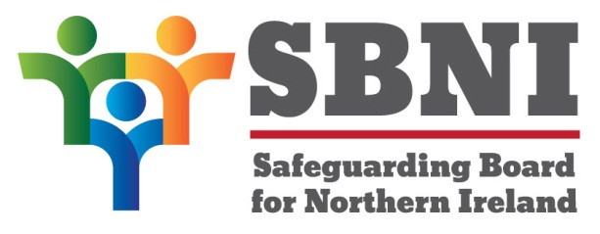
Public Section
45th Meeting of the Safeguarding Board for Northern Ireland
Wednesday 17th February 2021
Public meeting – 3.00pm – 4.30pm
PUBLIC AGENDA

Item Number | Item | Paper | Purpose | Responsibility
 | Welcome |  |  | Chair
 | Preliminaries: Apologies, Declaration of Interest, Complaints |  |  | Chair
1 45/21P | Previous Minutes | BM44-12.20PM | Approval | Chair
2 45/21P | Matters Arising | BM45-02.21MA |  | Chair
3 45/21P | Peer Mentoring Report | BM45-02.21P1 | Noting | Chair
4 45/21P | Information Sharing Correspondence | BM45-02.21P2 | Noting | Chair
5 45/21P | Finance Year End Report | BM45-02.21P3 | Noting | Chair
6 45/21P | Safeguarding Panel Induction Booklet | BM45-02.21P4 | Approval | Chair
7 45/21P | Programme for Government Consultation | BM45-02.21P5 | Noting | Chair
8 45/21P | Licensing and Registration of Clubs Amendment Bill | BM45-02.21P6 | Noting | Chair
9 45.21P | Online Safety Strategy | BM45-02.21P7 | Noting | Chair
 | AOB
 | Date of next meeting: Wednesday 28th April 2021

