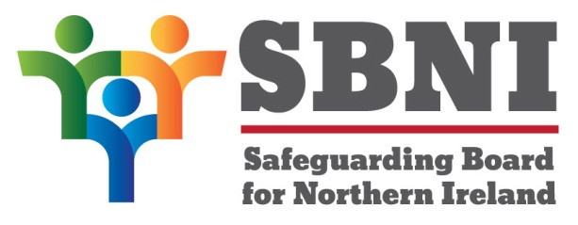
Public Section
47th Meeting of the Safeguarding Board for Northern Ireland
Wednesday 9th June 2021
Public meeting – 2.15pm – 4.30pm
PUBLIC AGENDA

Item Number | Item | Paper | Purpose | Responsibility
 | Welcome |  |  | Chair
 | Preliminaries: Apologies, Declaration of Interest, Complaints |  |  | Chair
1 47/21P | Previous Minutes | BM46-04.21PM | Approval | Chair
2 47/21P | Matters Arising | BM47-06.21MA | Approval | Chair
3 47/21P | CDOP Review Update | Presentation | Noting | Ms McEneaney
4 47/21P | Multi agency Response to Covid 19 & associated early intervention and support | Presentation | Noting | CS McNally
2.50pm -3.00pm | Break
5 47/21P | Home Office Safeguarding Unit | Presentation | Noting | Mr Walsh
6 47/21P | Northern Ireland NGO Stakeholder Report to inform UN Committee on RC ‘List of Issues’. | BM47-06.21P1 | Noting | Chair
7 47/21P | Domestic Abuse – Story Board | BM47-06.21P2 | Approval | Ms McAllister
8 47/21P | CMR Evaluation Report | BM47-06.21P3 | Noting | Mr Thomson
9 47/21P | Our Minds Our Future Charter | BM47-06.21P4  Our Minds Our Future | Approval | Ms McKenzie
10 47/21P | Board Meetings 2022 | BM47-06.21P5 | Noting | Chair
11 47/21P | AOB
 | Date of next meeting: Wednesday 15th September 2021

