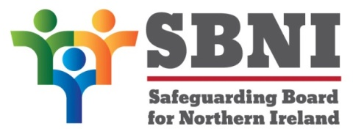
Public Section
48th Meeting of the Safeguarding Board for Northern Ireland
Wednesday 15th September 2021
Public meeting – 3.00pm – 5.00pm
PUBLIC AGENDA
Item Number | Item | Paper | Purpose | Responsibility
 | Welcome |  |  | Chair
 | Preliminaries: Apologies, Declaration of Interest, Complaints |  |  | Chair
1 48/21P | Previous Minutes | BM47-06.21PM | Approval | Chair
2 48/21P | Matters Arising | BM48-09.21MA | Approval | Chair
3 48/21P | Disclosure and Barring Scheme | Presentation | Noting | Mr Allister Woods
4 48/21P | Engagement with Children & Young People Strategy 2021 | BM48-09.21P1 | Approval | Ms Helen McKenzie
5 48/21P | Annual Report 2020 - 2021 | BM48-09.21P2 | Noting | Chair
6 48/21P | Finance Update Report | BM48-09.21P3 | Approval | Chair
7 48/21P | Declaration of Assurance Mid-Year September 2021 | BM48-09.21P4 | Approval | Chair
8 48/21P | Publication of Guidance on Information Sharing for Child Protection Purposes | BM48-09.21P5 | Noting | Chair
9 48/21P | Adoption and Children Bill Consultation | BM48-09.21P6 | Noting | Chair
10 48/21P | Call for Evidence – Justice Sexual Offences and Trafficking Bill 2021 SBNI Response | BM48-09.21P7 | Approval | Chair
11 48/21P | Harmful Sexual Behaviour Child Protection Policy – April 2021 | BM48-09.21P8 | Approval | Ms Maura Dargan
12 48/21P | Board Development Day | BM48-09.21P9 | Noting | Chair
13 48/21P | AOB |  | Noting | Chair
 | Date of next meeting: Wednesday 8th Dec 2021

