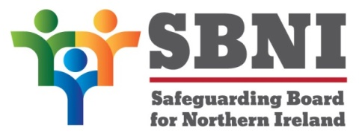
Public Section
49th Meeting of the Safeguarding Board for Northern Ireland
Wednesday 8th December 2021
Public meeting – 4.00pm – 5.00pm
PUBLIC AGENDA
Item Number | Item | Paper | Purpose | Responsibility
 | Welcome |  |  | Chair
 | Preliminaries: Apologies, Declaration of Interest, Complaints |  |  | Chair
1 49/21P | Previous Minutes | BM48-09.21PM | Approval | Chair
2 49/21P | Matters Arising | BM49-12.21MA | Approval | Chair
3 49/21P | Trauma Informed Practice Update.  The Salvation Army Trauma-Informed Inquiry Pilot Project (Ireland Region - 2021) | Presentation | Noting | Mr Simon Rogers  Ms Dawn Richardson  Dr Claire Luscombe  Mr Lee Ball
4 49/21P | The Domestic Abuse Information-sharing with Schools Regulations (Northern Ireland) 2022; Response from the Safeguarding Board for NI – Operation Encompass | BM49-12.21P1 | Approval | Ms Bronagh Muldoon
5 49/21P | Risk Register Update | BM49-12.21P2 | Noting | Mr Gerry Guckian
6 49/21P | DoH Revised and updated Protocol between Northern Ireland and Ireland for Handling Inter-jurisdictional Child Cases | BM49-12.21P3 | Noting | Ms Maura Dargan
7 49/21P | Annual Report 2020 - 2021 | BM49-12.21P4 | Approval | Chair
8 49/21P | AOB |  | Noting | Chair
 | Date of next meeting: Wednesday 16th February 2022

