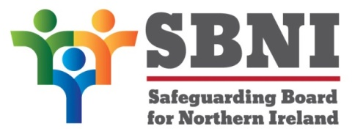
Public Section
54th Meeting of the Safeguarding Board for Northern Ireland
Wednesday 7 December 2022
Public meeting – 3.15pm – 4.30pm
PUBLIC AGENDA
Item Number | Item | Paper | Purpose | Responsibility
 | Welcome |  |  | Chair
 | Preliminaries: Apologies, Declaration of Interest, Complaints |  |  | Chair
1 54/22P | Previous Minutes | BM53-09.22PM | Approval | Chair
2 54/22P | Matters Arising | BM54-12.22MA | Approval | Chair
3 54/22P | Asylum Seeker Children and Families living in Contingency Accommodation | BM54-12.22P1 | Noting | Chair
4 54/22P | Children’s Social Care Services Review | __________ | Noting | Chair
5 54/22P | Governance Update: Risk Register | BM54-12.22P2A  BM54-12.22P2B  BM54-12.22P2C | Approval | Mr Gerry Guckian
6 54/22P | Annual Report 2021 – 2022 | BM54-12.22P3A  BM54-12.22P3B | Approval | Chair
7 54/22P | Policy and Procedures:  - Child Protection Registration Appeals process  - Sexually Active Children Guidance  - Signs of Safety  - Management of Allegations made against Staff | BM54-12.22P4A  BM54-12.22P4B  BM54-12.22P4C  BM54-12.22P4D  BM54-12.22P4E  BM54-12.22P4F  BM54-12.22P4G  BM54-12.22P4H  BM54-12.22P4I | Approval | Ms Maura Dargan
8 54/22P | Consultations | BM54-12.22P5 | Noting | Chair
9 54/22P | Deputy Secretary/ Chief Social Worker – Change in arrangements | BM54-12.22P6 | Noting | Chair
10 54/22P | AOB
Date of next meeting:
15 February 2023

