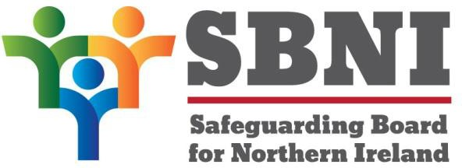

Consultation questions
Tell us what you think about our plan

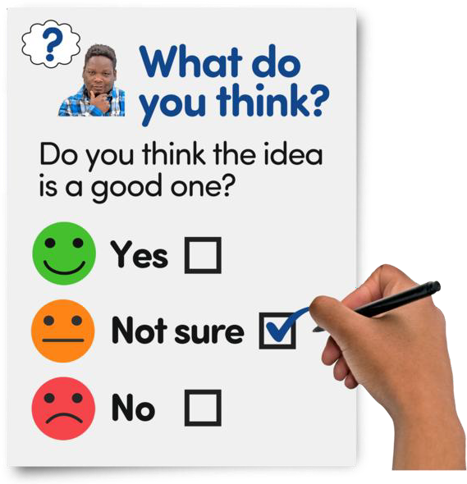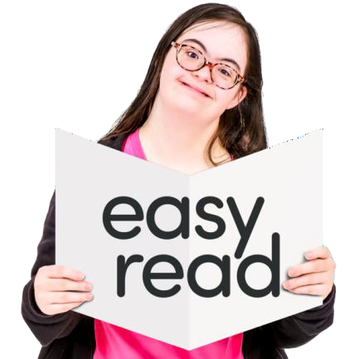

Tell us what you think about our 4 year plan to keep children safe

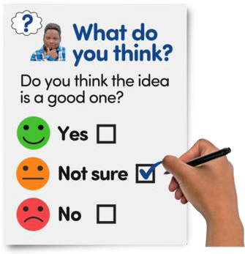
Consultation means asking people what
About this consultation
they think to help make a good plan.

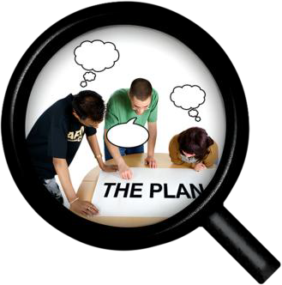
Consultations give people a chance to share their ideas and views.

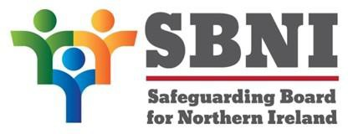
The Safeguarding Board for Northern Ireland works to keep children and young people safe.

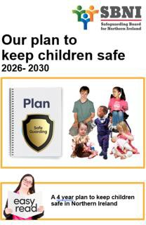
We are asking for your views on our
Strategic Plan 2026–2030.

This plan explains our work for the next 4
years to help keep children safe.

2


We want to know what you think about our
We want to know what you think

- mission – what we do

- vision – what we want

- values – what guides our work


- strategic priorities– what we focus on

We want to hear from
- children and young people

- parents and carers

- organisations that work with children

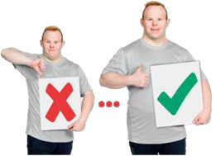
- members of the public.

Your answers will help make our plan
better.

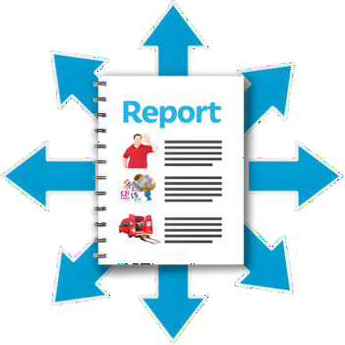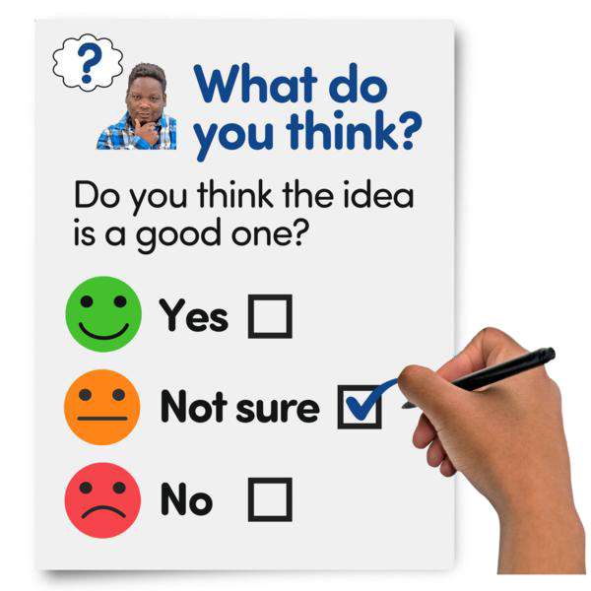We will write a summary of what everyone
tells us after the consultation.

We will share this with everyone.

Please tell us if you want what you say to be kept private or to not have your name used.

3


Fill in your answers on this document.
How to tell us what you think

Save and email it to SBNI.info@hscni.net


You can also complete the questionnaire on our website The SBNI Strategic Plan 2026-2030 - Easy Read Consultation Questionnaire – Fill in form

Deadline


You must send your answers by midnight on 23 February 2026.


Anything sent to us after this date will not
be used.

4


We ask for information about you to help us understand who is answering our questions.
Your information

Your information will only be used for this consultation.

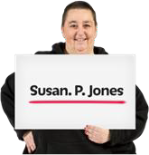
Your name


Your email address

Who are you answering questions as?

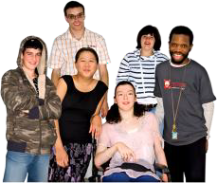

Organisation

Other

Individual
or group

5

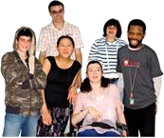

If you ticked organisation or group.

Tell us the name of the organisation or group.

If you ticked other.


Tell us more about who you are.

6

Our mission, vision, and values

Mission – what we do


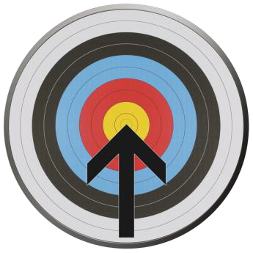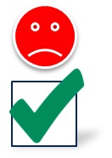We work together to keep children and young people safe from harm.

Question 1

Do you think our mission clearly explains what we do?

Yes
No

Question 2

If you ticked no.
What do you think it should say?

7

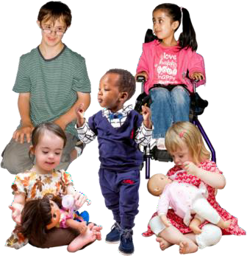
We want all children and young people to be listened to and feel safe so they can grow and do well.
Vision – what we want

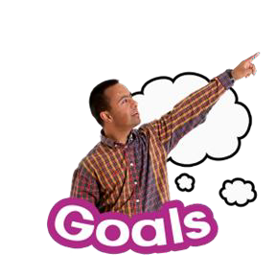Question 3

Do you think our vision clearly explains what we want to make happen?

Yes No

Question 4

If you ticked no.
What do you think it should say?

8

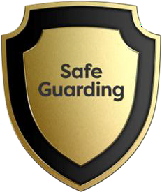
We protect children and young people, especially those most at risk of being hurt.
Values – what guides our work

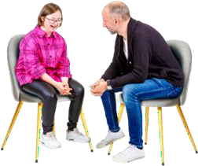
We listen to children and young people to
understand what they want.

We put them at the centre of our work.


We work together to keep children and young people safe and support their rights.

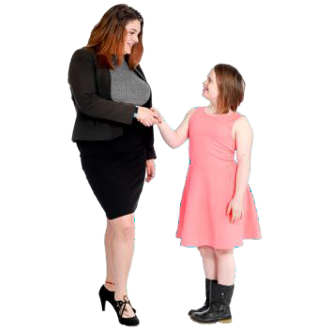
We respect and support everyone who
works with us and aim to do our best.

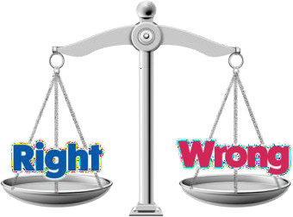
We are honest, kind, and clear with everyone.

We respect differences and treat everyone fairly.

9

Question 5

Are our values what you would expect from us?
Yes No

Question 6

If you ticked no.
What do you think it should say?

10

Our Strategic Priorities
What we will focus on
11



Priority 1.

We lead and guide how to keep children and young people safe and well.

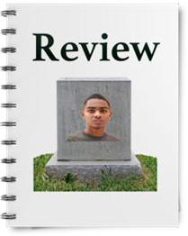
Make sure Case Reviews and Panels
follow the law.

Make sure they do everything they need to.

Case reviews are meetings to look at a person’s
situation and decide the best care or support.

Panels are groups of people who meet to discuss cases and make decisions or give advice.


Make sure groups that give advice or help make decisions do what they said they would.

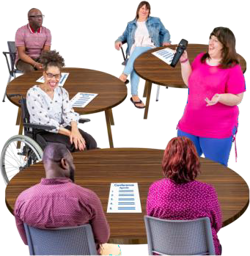
Take part in safeguarding meetings across
Northern Ireland.

Safeguarding means keeping children safe from abuse, neglect, and harm.

11

Question 7

Do you agree with Priority 1?

Yes No

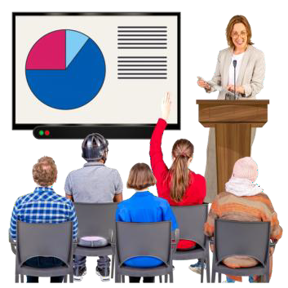

Question 8

If you ticked no.
What do you think it should say?

12

Question 9

Do you agree with what we say we will do as part of Priority 1?
Yes No

Question 10

If you ticked no.
What do you think we should do?

13

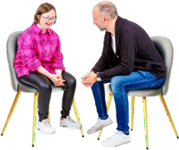
Priority 2.

Listen to children affected by domestic violence and abuse and respond.

Domestic violence and abuse is when someone
at home hurts or controls you.

Work with government groups to help children, young people, and adults learn about

- healthy relationships and

- stopping domestic violence and abuse.


Help parents, carers, and workers
understand domestic violence and abuse.


Share how to keep children safe and recover from it.

Support children to report domestic violence and abuse safely.

14

Question 11

Do you agree with Priority 2?

Yes No

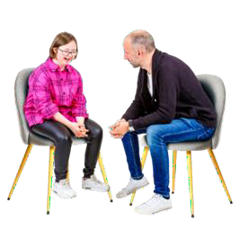

Question 12

If you ticked no.
What do you think it should say?

15

Question 13

Do you agree with what we say we will do as part of Priority 2?
Yes No

Question 14

If you ticked no.
What do you think we should do?

16



Priority 3.

Help children and young people use the internet safely and without harm.

Work with government to improve online safety.

Teach children, families, and workers how to stay safe online.

17

Question 15

Do you agree with Priority 3?

Yes No



Question 16

If you ticked no.
What do you think it should say?

18

Question 17

Do you agree with what we say we will do as part of Priority 3?
Yes No

Question 18

If you ticked no.
What do you think we should do?

19

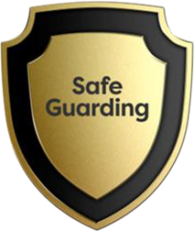
Priority 4.

Protect children and young people
from all types of exploitation.

Child exploitation is when adults take advantage of children.

Work with the government to stop children and young people being exploited.


Help children, parents, carers, and professionals understand child exploitation and how to stop it.


We work with partners to create tools to help spot signs of child exploitation.

20

Question 19

Do you agree with Priority 4?

Yes No

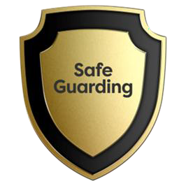

Question 20

If you ticked no.
What do you think it should say?

21

Question 21

Do you agree with what we say we will do as part of Priority 4?
Yes No

Question 22

If you ticked no.
What do you think we should do?

22

Question 23

Are there any other priorities the SBNI should include?

23

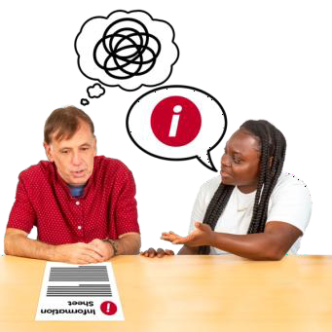Question 24

Is our draft plan easy to understand?
Yes No

Question 25

If you ticked no.
What do you think would make it easier to
understand?

24

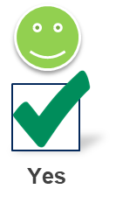

Question 26

Is anything missing from our plan?
Yes No

Question 27

If you ticked yes.
What do you think is missing?

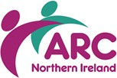


© Easy Read created by TILII Translates November 2025 all rights reserved. Not to be reproduced in whole or part without permission.

