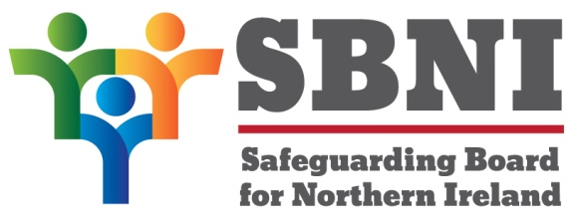

The Safeguarding Board for Northern Ireland (SBNI)

The SBNI Strategic Plan 2026-2030

Response to Equality and Human Rights Screening

If you require this document in an alternative format (such as large print, Braille, disk, audio file, audio cassette, Easy Read or in minority languages to meet the needs of those not fluent in English), please contact alex.mccoy@hscni.net

Do you have any comments on the issues identified in the screening template under 2.2 (the equality profile of those affected by the policy) and 2.3 (the needs of different equality groupings in relation to the policy)?

Can you identify any further equality issues?

Do you think that the actions we are taking to address the equality issues (see 2.5) will be sufficient?

Do you have any suggestions for further actions to address the equality issues?

Do you agree with the screening decision (see 3)?
If not please explain and provide relevant supporting evidence.

Do you have any suggestions to further promote equality of opportunity for any of the nine equality groups?

Do you have any comments on the issues identified in the human rights screening template under section 5?

